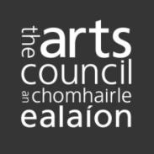
IRIS: Memorandum of Understanding

This memorandum MUST be explicitly agreed with each partner organisation. The Arts Council assumes that both parties are fully aware of, and committed to, its contents.

Applicant information
Please enter name of applicant organisation and total amount of financial resource invested towards the residency initiative of reference. The total amount should include the funding requested from the Arts Council.
Applicant: | Total amount

Parties to the memorandum
Please enter name of partner organisation and total amount of financial resource invested towards the residency initiative of reference.
Partner organisation: | Total amount
Partner organisation: | Total amount
Partner organisation: | Total amount
Partner organisation: | Total amount

Proposal overview
Please summarise in no more than three short bullet points what you want to do and how (max. 300 characters including spaces/approx. 50 words). Text should be same as in application.

Residencies information
Country  Country  Country  Country | Number of residencies:  Number of residencies:  Number of residencies:  Number of residencies:

Declaration of agreement
On behalf of the applicant:
Name: Position:
On behalf of the partner organisations:
Name: Position:
Name: Position:
Name: Position:
Name: Position:

